# ASTRO 205: Problem Set 2

## Question 1

### Part A

To relate both the declination and right ascension to the stars together, they both have to be in the appropriate angle system.

So, for the right ascension, an hour is $\frac{15pi}{180}$ rad, a minute is $\frac{15pi}{60\left(180\right)}rad$, and a minute is $\frac{15pi}{3600\left(180\right)}rad$.

For the declination, a degree is $\frac{pi}{180}$ rad, an arcminute is $\frac{pi}{(60)180}$ rad, and an arcsecond is $\frac{pi}{3600(180)}$ rad.

By just plotting them on a normal scatter plot.

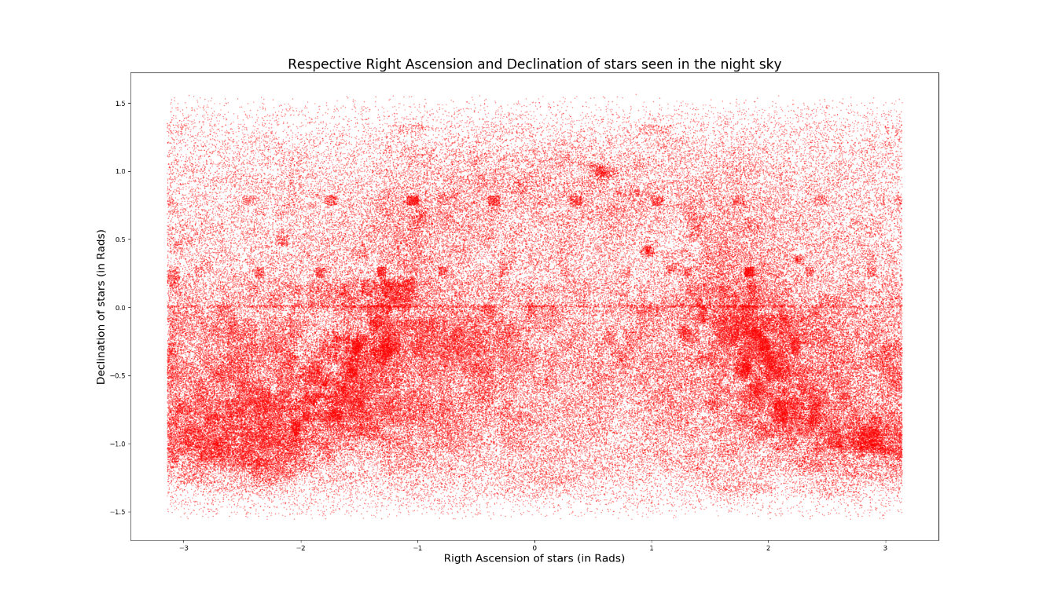

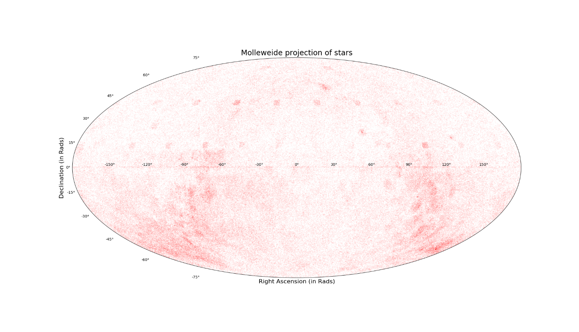Though this plot shows that the groups of stars with the same declination and right ascensions parallel to each other, this plot could be better examined via the given projection.

Ensuring that the right ascension is accounted for from 0 to 360 degrees to -180 to 180 degrees. This projection shows that there are fewer clumps of stars at the 0 degrees in comparison to the 90 and -90 degrees mark. There are clumps of stars at 15 degrees declination and the 45 degrees declination that seem to be parallel to each other.

### Part B

By filtering out the stars that have an apparent magnitude of 6 or below (brighter) the plot is as such

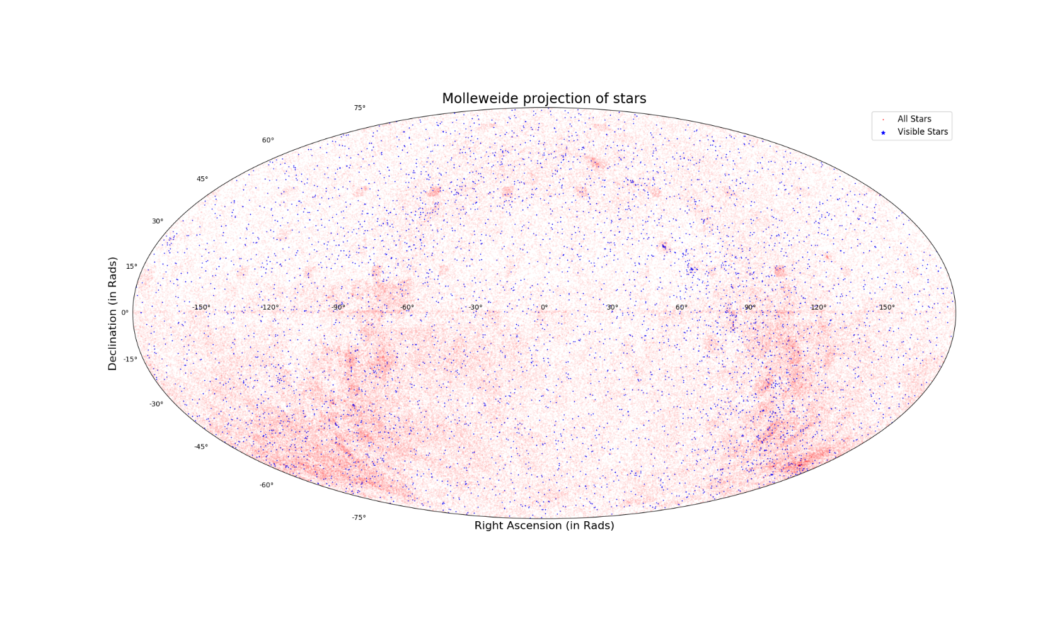

Where the visible stars are highlighted in blue. **There are 5074 visible stars**. It would seem to be that all visible stars are scattered randomly (and evenly) in the sky. With no discernible pattern.

### Part C

Circumpolar stars (from Vancouver) are stars that have a declination more than the zenith (90 degrees) subtracted by the latitude, so that they are above the horizon at all time (thus never set).

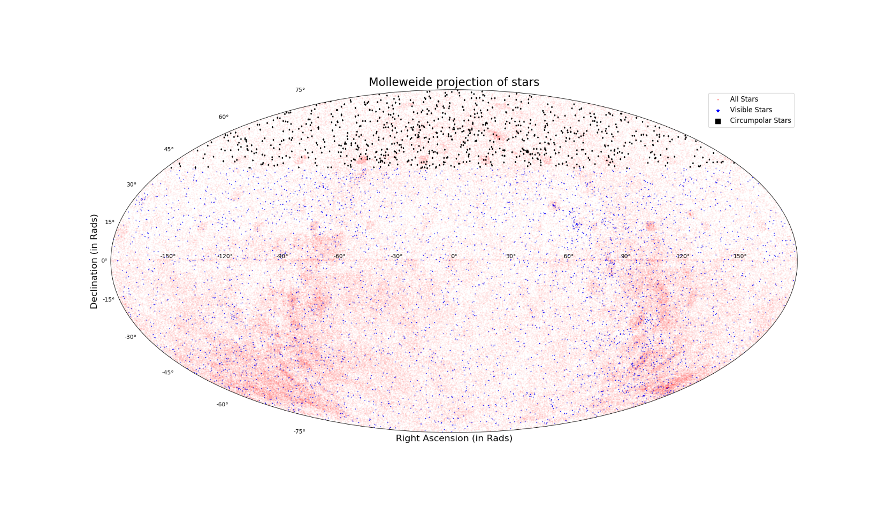

**There are 860 visible circumpolar stars.**

## Question 2

### Part A

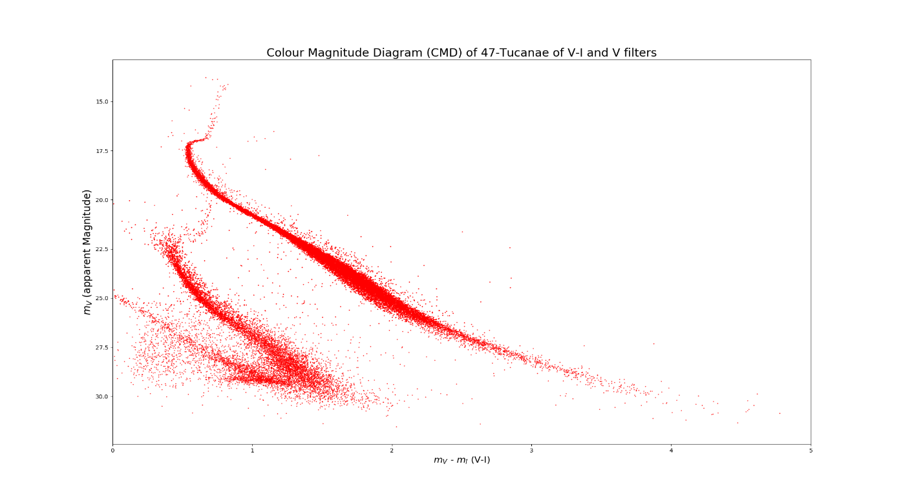

In order to ensure the apparent magnitude is set from the least bright to brightest, the axis from the apparent magnitude had to be flipped. From the plot, three main branch like structures can be seen, with a lot of random dispersion (noise) around the branch closest to the y-axis. Its quite clear that the one closest to the middle must represent the main sequence stars (burning hydrogen) as it looks quite identical to the shape in the Hertzsprung-Russel diagram. Where the top part represents the Red hot Supergiants around the end of their main sequence lifetime. The branch closest too them (to the left) slightly looks like the same thing yet very shortened and contracted. This, by intuition, most likely represents stars in another cluster/cloud in the background of 47 Tucanae and not actually in the cluster itself. Lastly the branch to the far most left must represent the white dwarfs in the cluster, which are less bright than main sequence stars. The “Fuzziness” around the branches (especially around the last two mentioned) could be representing other stars in the background that are not part of either system or a fact of bad measurement taking.

### Part B

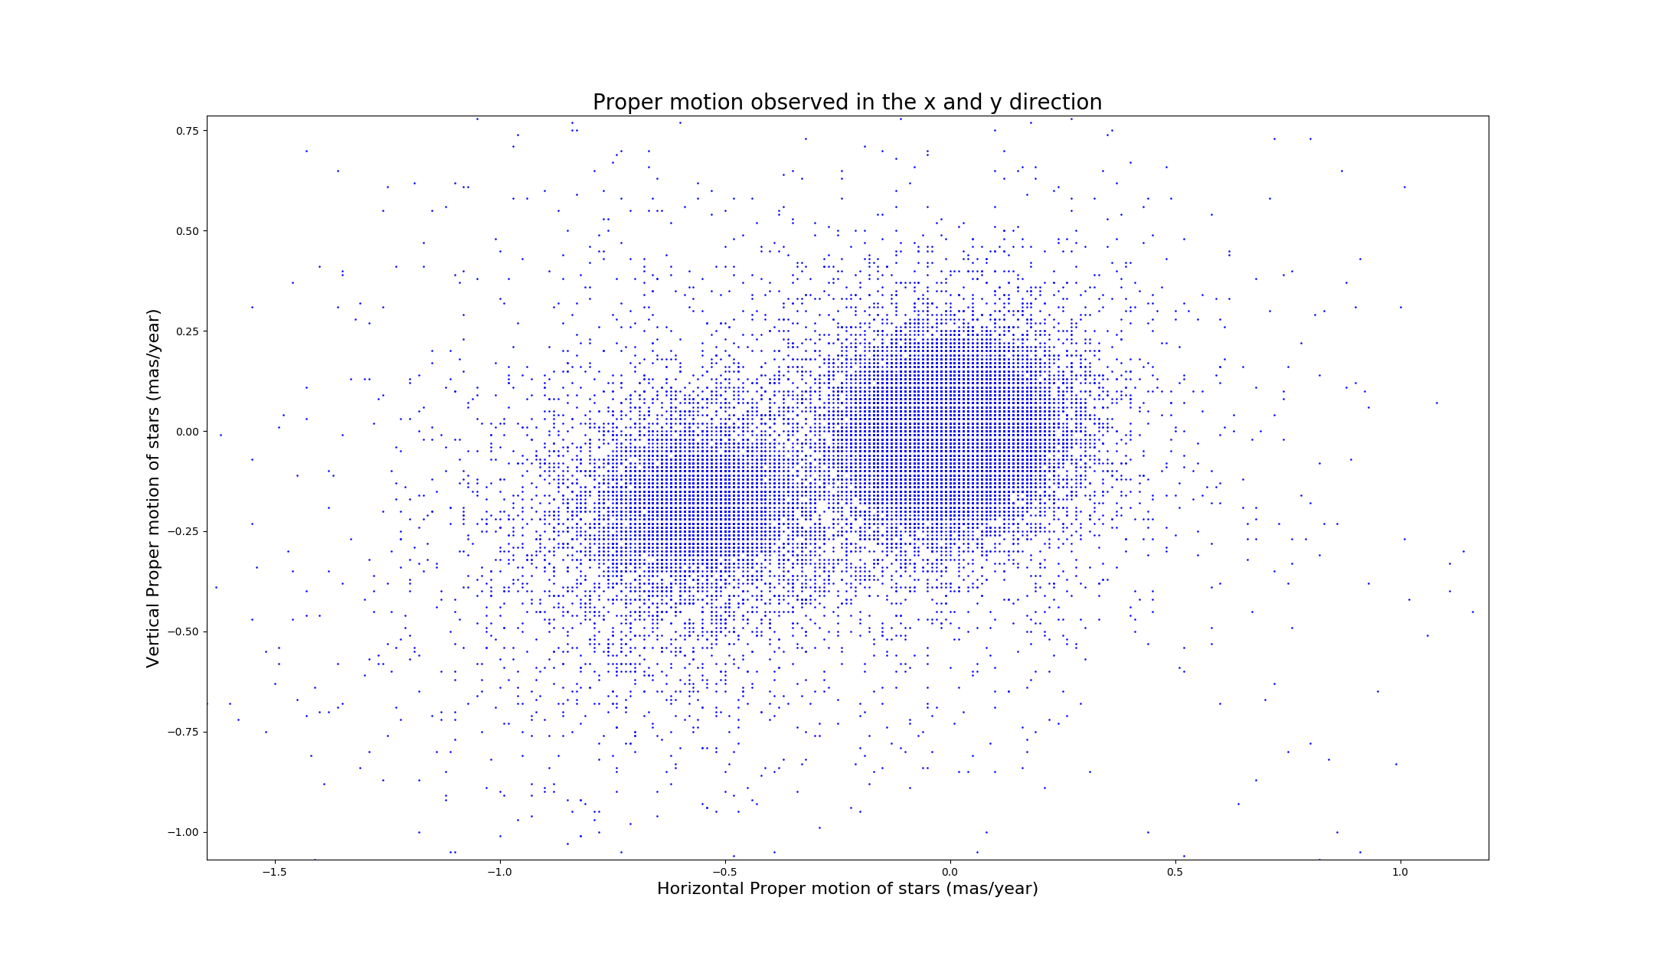By just plotting the proper motion of the stars, we get the plot above. From just a plain observation, it would it seem that most of the stars are collected in the radius of the circle (centred around the origin). However, when zooming in on the centre.

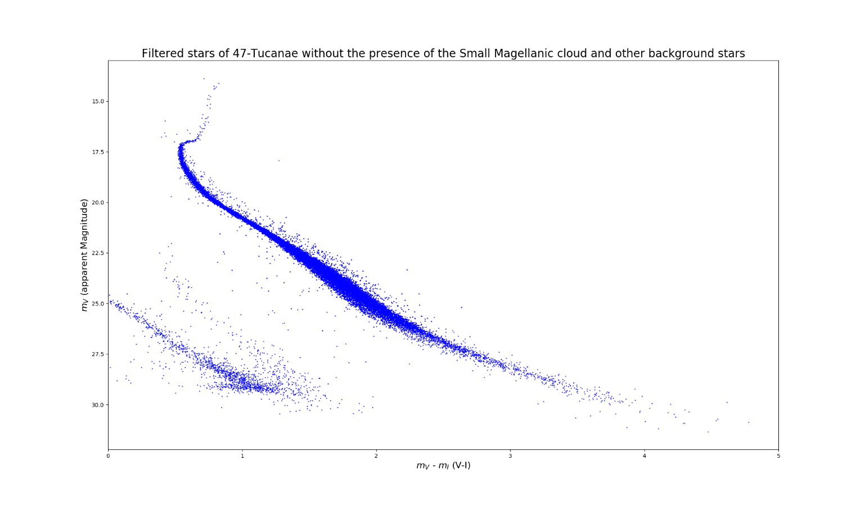It can be seen that the centre of the circle is actually comprised of 2 circles. One representing the motion in 47 Tuc and one representing the motion of the background stellar cluster (Small Magellanic Cloud (SML)). As this data is focused on 47 Tuc, the proper motion of stars in that cluster should average out to the 0, as the stars are moving along together. Thus, the clusters of stars on the right side must be representing 47 Tuc and the cluster on the left must represent the SML. So by sectioning off (with as much as human accuracy) the two circles from each other, we can separate the two clusters. Whereas, all the stars that do not fit in the radius of the circle (more or less) are treated as the background stars unrelated to either system

### Part C

The plot above shows the stars of 47 Tuc filtered from the stars in the SML. The technique used can be considered effective due to the fact that the second branch (in between the leftmost and the rightmost branch) is almost completely gone, which shows that main sequence stars of the SML have been correctly identified and filtered out. Further strengthened by the fact that the other two branches have been, basically, unaffected and in turn, unrelated to the stars filtered out (thus, part of 47 Tuc). The fact that some stars remain in place of the second branch show that the range of stars filtered out could better be filtered out (for better accuracy) or that some of the data given could have been wrongly taken.

### Part D

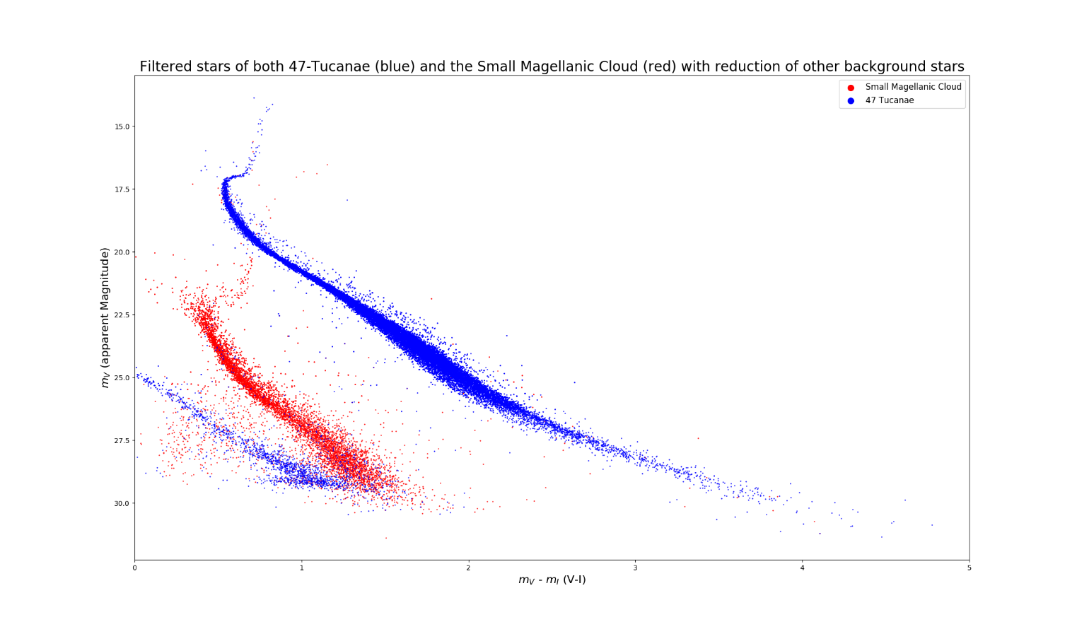Overlaying the stars from both the SML and 47-Tuc.

Knowing that both the red branch and the leftmost branch represent the main sequence of stars in both clusters, I can compare the similarities of both to understand the actual distance to the SML. By using the topmost parts of the branches, where they curve towards the right before the exponentially rise (the Supergiant stars) and **assuming the absolute magnitude of both stars at that point (respectively in 47 Tuc and the SML) are the same.**

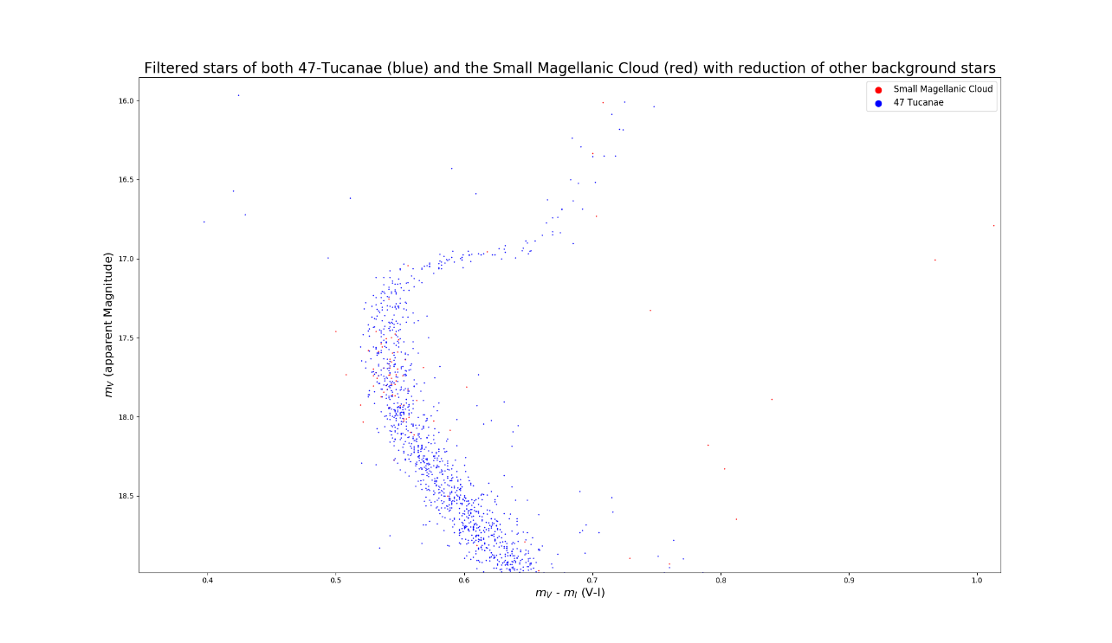

Zooming into 47 Tuc, the supergiant being referred to is the star inside the highlighted box with the highest apparent magnitude (star lowest in the box).

After finding that the $m_{V}$ (Apparent magnitude of the star in the visible spectrum) is 17.043 and the distance to this star is 4000 pc. Using the distance modulus formula, $M_{V}$ (Absolute magnitude in the visible spectrum) can be defined.

$$m_{V}-M_{V}=5logd-5$$

$$M_{V}=m_{V}+5-5logd$$

Where in this case $M_{V}$ **is 4.03**

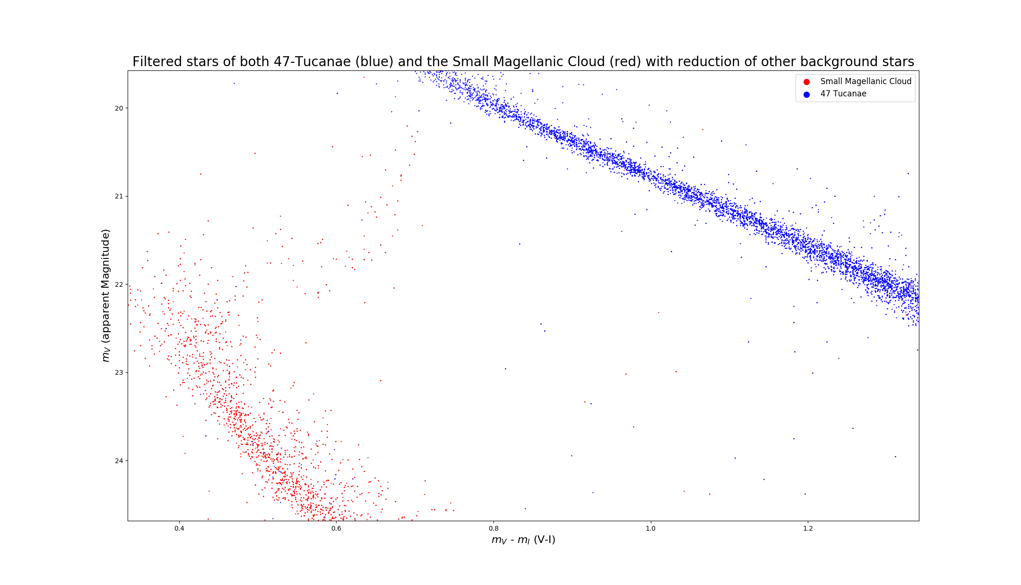

Now taking the highest apparent magnitude star of the similar bend in the SML (Within the dimensions of the box) and assuming that star has the same absolute magnitude as the star in 47 Tuc, the distance can be reached;

**The $m_{V}$ is 22.02**

$$m_{V}-M_{V}=5logd-5$$

$$d={10}^{\frac{m_{V}-M_{V}+5}{5}}, Where d is in pc$$

Thus, yielding a **distance to the Small Magellanic Cloud to be 39.6 Kpc**

Where, according to online sources, the actual distance to SML is closer to 60 Kpc. Thus, our distance attained is within a factor of 2 to the actual answer. This is most likely due to the fact that we assumed the same the absolute magnitude for both stars, which would probably vary a lot with the actual absolute magnitude of the star in the SML. Furthermore since the stars in the SML in the plot are a lot fewer than compared to 47 Tuc, the location at which the bend occurred was much fainter and probably was not as precise as it could have been if more data was more provided. Thus saying they are both Supergiants at the same part of the main sequence may not the most accurate decision.